IS MALE MORE DIFFICULT THAN FEMALE TO GET ADMITTED INTO TOP UNIVERSITY

Xin Tang

Bellevue University

Abstract

In lieu of recent fair admission lawsuit against Harvard University's undergraduate admissions process, which is claimed to discriminate against Asian American applicants, There is another common impression in Asian community that males are more difficult to get admitted into top university than female peers, this study is intended to validate if this is a true statement, by using data from top level universities, including those from Ivy Leagues and some other commonly acknowledged top schools.

Keywords: college admission, male, female.

GENDER FACTOR ON COLLEGE ADMISSION

# INTRODUCTION

Westwood high school, which my kids are attending, is the most competitive school in the city. Every year there are quite a few students who get admitted into Ivy school, or, if affordability is a concern, the top public university. In 2022, all top 10 have been admitted into top 50 ranked US universities, including MIT and Harvard. Among these 10 students, Male to Female ratio is 6:3. On the other hand, among the Asian community, there is also a common impression that, due to gender balance/diversity concern, at similar academic level and background, female is more likely get admitted in than male students. From the neighborhood I lived in, I had heard 5 girls living close by got admission to top universities in 2022, but hardly heard any news related to boys. So, I am interested in exploring more on this topic.

## Questions to ask before research

To answer the question: “is male more difficult than woman to get admitted into top universities?” to narrow down the research. Here are a few questions I am trying to find answers:

* + Is there any search trend in male/female admission?
  + Is there any search trend in gender-based admission discrimination?
  + What is the male to female ratio in Westwood high school?
  + What is the male/female undergraduate enrollment ratio in Harvard?
  + What is the national gender-based admission rate?
  + Where is the data resource I can use?

## Preliminary findings:

There are many more searches on fair admission than admission based on gender. This could be an indication that this may not be a common concern. At the same time, Harvard did admit more female student than male student in class 2026. Another interesting finding is that much more female student continue pursue the college degree than male. So, the female dominating of admission may not be due to discrimination, but due to some other factors, like more male decide not to continue college education, but to start working after high school graduation,

References

Fair admission vs college admission gender search trend – Google trend.

<https://trends.google.com/trends/explore?date=today%205-y&geo=US&q=college%20admission%20gender,fair%20admission>

College admission gender search –Google trend

<https://trends.google.com/trends/explore?date=today%205-y&geo=US&q=college%20admission%20gender>

Harvard College Admits Class of 2026 (Mar-022) - The Harvard magazine

<https://www.harvardmagazine.com/2022/03/harvard-college-class-2026-admissions>#

Westwood high school 2022 top 10 (May-2022) - RoundRock ISD

<https://roundrockisd.org/graduation/top-10/whs-2022-top-10/>

How can Asian American male application standout in admission –Quora

<https://www.quora.com/How-can-an-Asian-American-male-applicant-stand-out-in-college-admissions>

immediate-enrollment-in-college-of-high-school-completers-in-the-us-by-gender

–statistica <https://www.statista.com/statistics/478663/immediate-enrollment-in-college-of-high-school-completers-in-the-us-by-gender/>

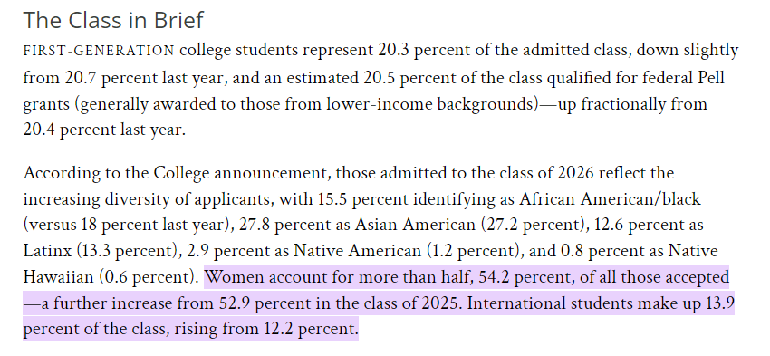

Figure 1. Harvard class 2026 admission diversity

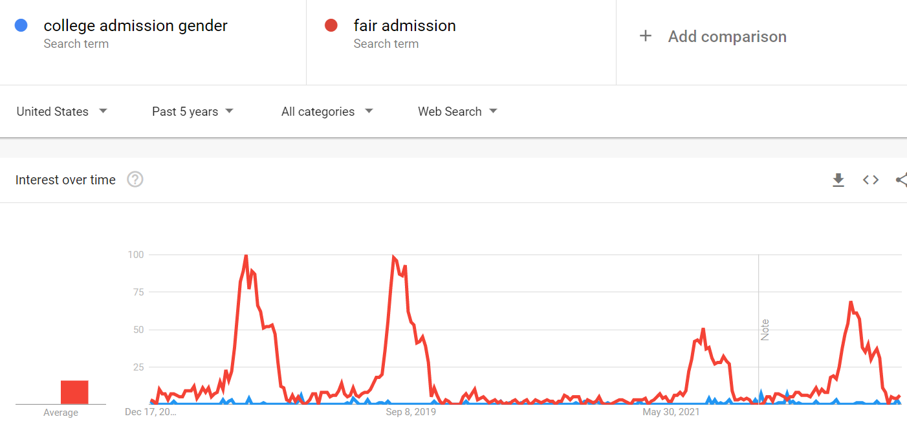

Figure 2. Google trend comparison between fair admission vs gender-based college admission

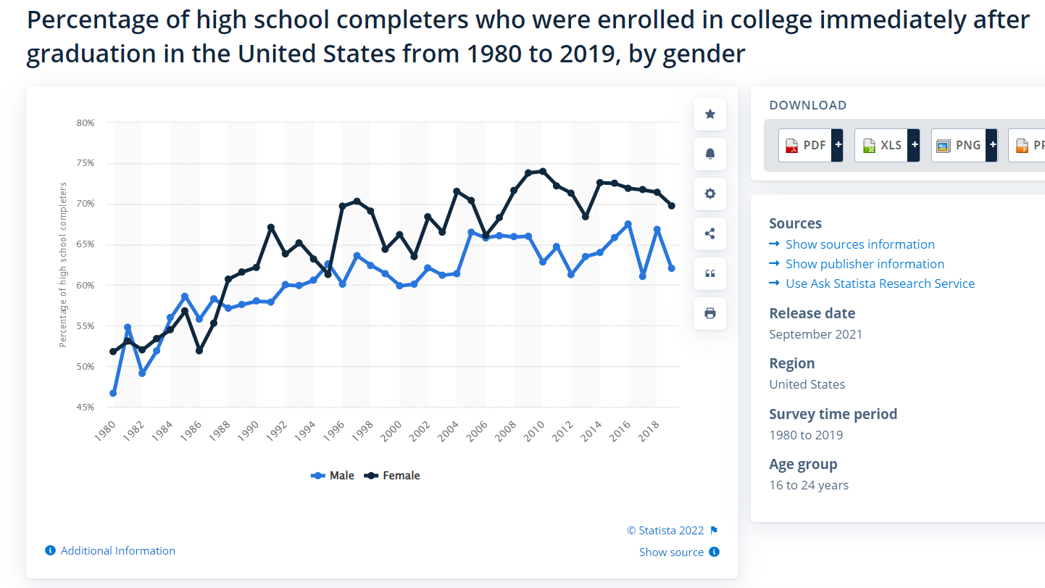

Figure 3. trend of high schooler who enrolled in college right after graduation, by gender